Coplanar Lines in Solid Geometry
# Source: AI Source: Provided by: [Data Path: Persons Table -> ID Column: 1, Name_En Column: Motasem Essam] -> From: [ChatGPT] on [7/25/2026]
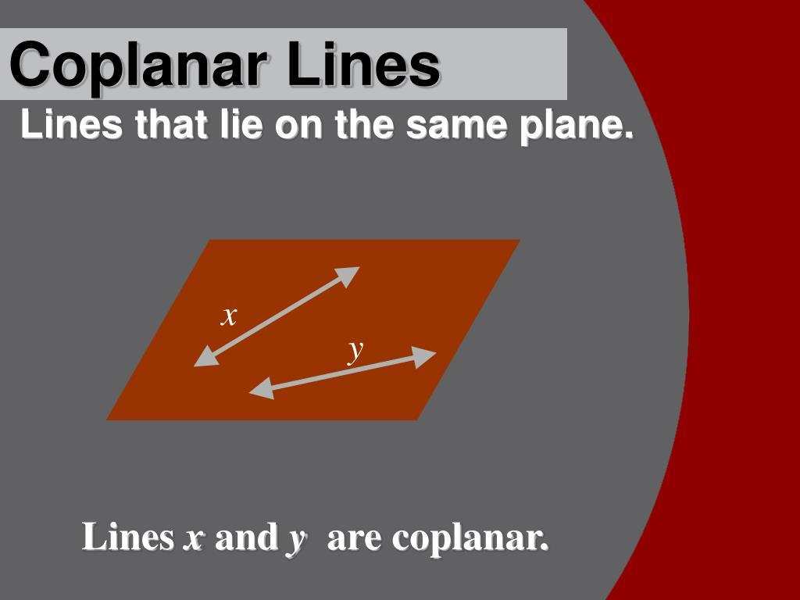
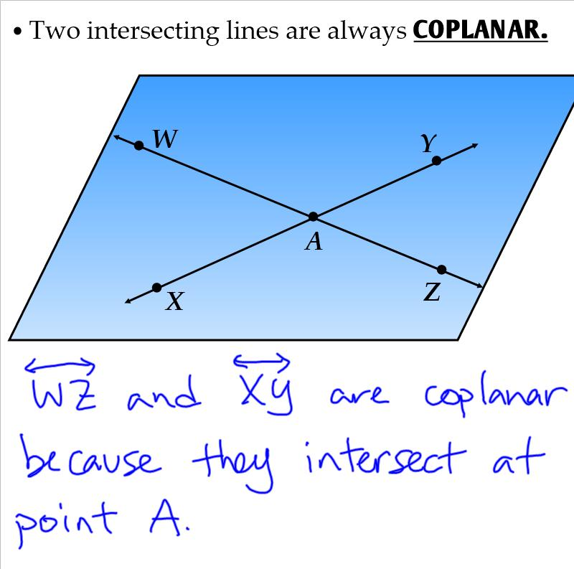
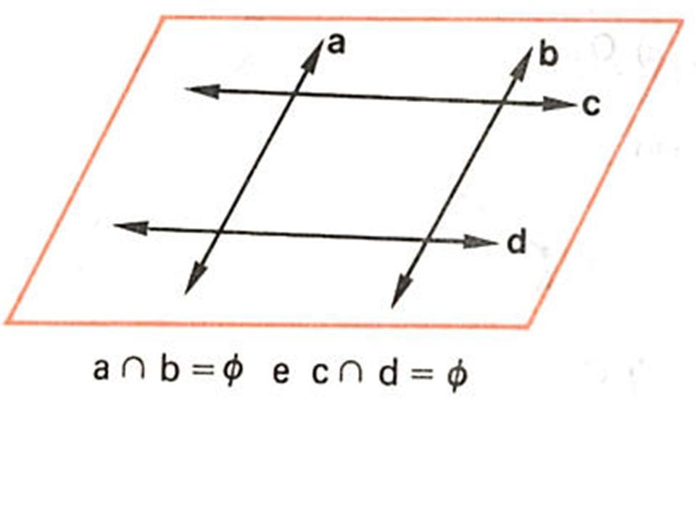

Definition
# Source: AI Source: Provided by: [Data Path: Persons Table -> ID Column: 1, Name_En Column: Motasem Essam] -> From: [ChatGPT] on [7/25/2026]
Coplanar lines are two or more lines that lie in the same plane in three-dimensional space.
The lines may intersect, be parallel, or coincide. The defining property is that a single plane can contain all the lines.
In solid geometry, coplanarity is important because two lines in three-dimensional space are not necessarily in the same plane. Lines that are not contained in any common plane are called skew lines when they are distinct, non-parallel, and non-intersecting.

Simple Definition
# Source: AI Source: Provided by: [Data Path: Persons Table -> ID Column: 1, Name_En Column: Motasem Essam] -> From: [ChatGPT] on [7/25/2026]
Coplanar lines are lines that can all be drawn on the same flat plane.
Examples include:
- Two lines that cross each other on a flat sheet of paper.
- Two distinct parallel lines drawn on a tabletop.
- Two coincident lines occupying the same geometric line.

Key Characteristics
# Source: AI Source: Provided by: [Data Path: Persons Table -> ID Column: 1, Name_En Column: Motasem Essam] -> From: [ChatGPT] on [7/25/2026]
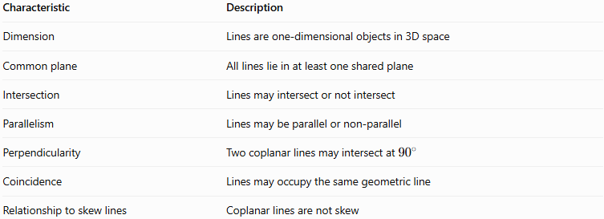
Characteristic | Description
Dimension | Lines are one-dimensional objects in 3D space
Common plane | All lines lie in at least one shared plane
Intersection | Lines may intersect or not intersect
Parallelism | Lines may be parallel or non-parallel
Perpendicularity | Two coplanar lines may intersect at ${90}^{∘}$
Coincidence | Lines may occupy the same geometric line
Relationship to skew lines | Coplanar lines are not skew
A single plane can contain infinitely many different lines. Coplanarity does not require the lines to intersect.

Types of Coplanar Lines

A. Intersecting coplanar lines
# Source: AI Source: Provided by: [Data Path: Persons Table -> ID Column: 1, Name_En Column: Motasem Essam] -> From: [ChatGPT] on [7/25/2026]
Two distinct lines that share exactly one point. They lie in the same plane and meet at their intersection.
Example: Two lines crossing on a sheet of paper.
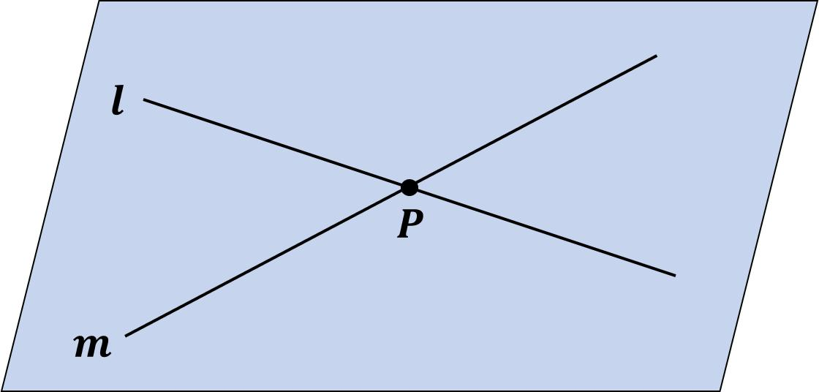

B. Parallel coplanar lines
# Source: AI Source: Provided by: [Data Path: Persons Table -> ID Column: 1, Name_En Column: Motasem Essam] -> From: [ChatGPT] on [7/25/2026]
Two distinct lines in the same plane that never intersect. Their direction vectors are scalar multiples of one another.
Example: The opposite edges of a rectangular tabletop.
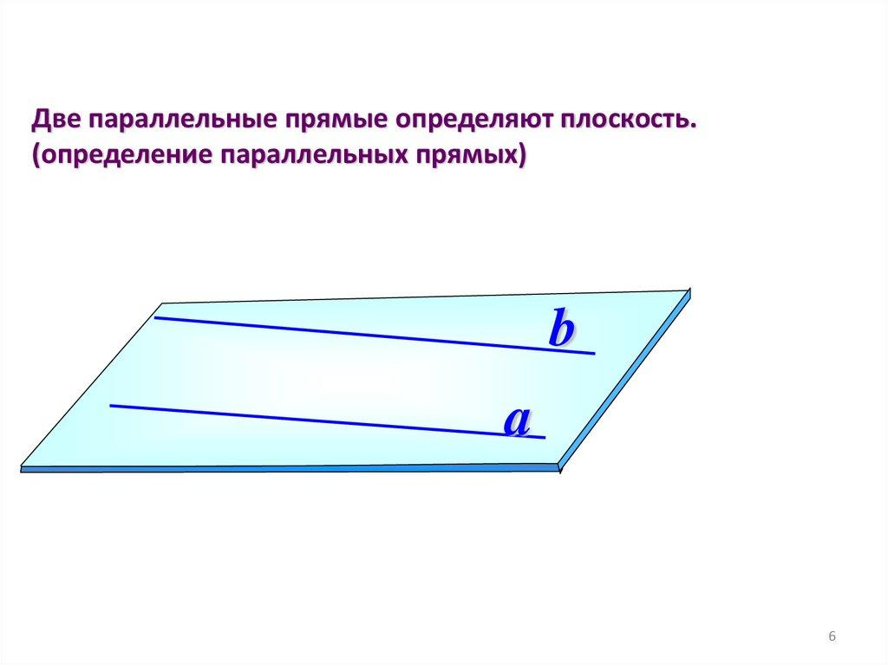

C. Perpendicular coplanar lines
# Source: AI Source: Provided by: [Data Path: Persons Table -> ID Column: 1, Name_En Column: Motasem Essam] -> From: [ChatGPT] on [7/25/2026]
Two coplanar lines that intersect at a right angle.
Example: Adjacent edges of a square.
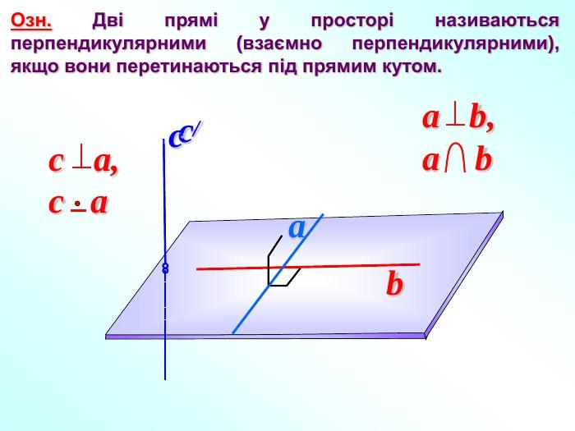

D. Coincident lines
# Source: AI Source: Provided by: [Data Path: Persons Table -> ID Column: 1, Name_En Column: Motasem Essam] -> From: [ChatGPT] on [7/25/2026]
Two lines that occupy exactly the same position and share every point. They are coplanar because any plane containing that line contains both representations of it.
Example: Two equations that describe the same geometric line.
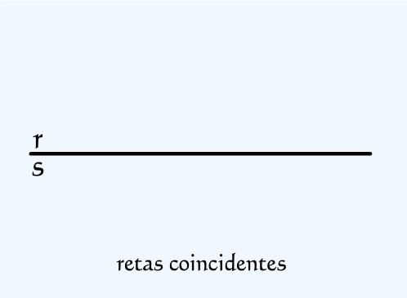

Mathematical Representation

A. Using a plane equation
# Source: AI Source: Provided by: [Data Path: Persons Table -> ID Column: 1, Name_En Column: Motasem Essam] -> From: [ChatGPT] on [7/25/2026]
A plane in three-dimensional space can be represented by
$$ax+by+cz+d=0$$
where $a,b,c,d$ are constants, with $a,b,c$ not all zero.
A point $\left(x,y,z\right)$ lies on this plane if it satisfies the equation. A line is contained in the plane if every point on that line satisfies the plane equation.
For example, the plane
$$z=0$$
is the $xy$-coordinate plane. The following lines both lie entirely in this plane:
$$L_{1}:\left(x,y,z\right)=\left(t,0,0\right)$$
$$L_{2}:\left(x,y,z\right)=\left(0,s,0\right)$$
Both have $z=0$ for every value of their parameters, so they are coplanar. They intersect at the origin $\left(0,0,0\right)$.

B. Using vector equations
# Source: AI Source: Provided by: [Data Path: Persons Table -> ID Column: 1, Name_En Column: Motasem Essam] -> From: [ChatGPT] on [7/25/2026]
Two lines can be written as
$$L_{1}:r=a+tu$$
$$L_{2}:r=b+sv$$
where $a,b$ are position vectors and $u,v$ are direction vectors.
If the direction vectors are not parallel, the lines are coplanar precisely when
$$\boxed{\left(b-a\right)⋅\left(u×v\right)=0}$$
This is the scalar triple product test. If the result is nonzero, the lines are non-coplanar and therefore skew.
If the direction vectors are parallel, the lines are coplanar regardless of the scalar triple product test above; the two lines may be distinct parallel lines or coincident lines.

Worked Examples
# Source: AI Source: Provided by: [Data Path: Persons Table -> ID Column: 1, Name_En Column: Motasem Essam] -> From: [ChatGPT] on [7/25/2026]
Example 1: Two intersecting coplanar lines
Consider
$$L_{1}:\left(x,y,z\right)=\left(t,0,0\right)$$
$$L_{2}:\left(x,y,z\right)=\left(0,s,0\right)$$
Both lines lie in the plane $z=0$.
For an intersection, set their coordinates equal:
$$\left(t,0,0\right)=\left(0,s,0\right)$$
This gives $t=0$ and $s=0$.
Therefore, the lines intersect at
$$\boxed{P=\left(0,0,0\right)}$$
Conclusion: The lines are coplanar and intersect at the origin.
Example 2: Two parallel coplanar lines
Consider
$$L_{1}:\left(x,y,z\right)=\left(t,0,0\right)$$
$$L_{2}:\left(x,y,z\right)=\left(s,2,0\right)$$
Both lines lie in $z=0$, and their direction vectors are identical:
$$u=v=\left(1,0,0\right)$$
They have different $y$-coordinates, so they never intersect.
Conclusion: The lines are distinct, parallel, and coplanar.
Example 3: Distinguishing coplanar lines from skew lines
Consider
$$L_{1}:\left(x,y,z\right)=\left(t,0,0\right)$$
$$L_{2}:\left(x,y,z\right)=\left(0,s,1\right)$$
Their direction vectors are $\left(1,0,0\right)$ and $\left(0,1,0\right)$, which are not parallel. The first line always has $z=0$, while the second always has $z=1$, so they cannot intersect.
Furthermore,
$$u×v=\left(0,0,1\right)$$
and the difference between their base points is $\left(0,0,1\right)$. Thus,
$$\left(b-a\right)⋅\left(u×v\right)=1≠0$$
Conclusion: These lines are non-coplanar and are therefore skew lines.

Comparison with Other Line Relationships
# Source: AI Source: Provided by: [Data Path: Persons Table -> ID Column: 1, Name_En Column: Motasem Essam] -> From: [ChatGPT] on [7/25/2026]
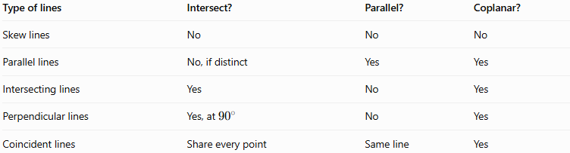
Property | Coplanar lines | Skew lines
Lie in a common plane | Yes | No
Can intersect | Yes | No
Can be parallel | Yes | No, by definition
Can be perpendicular | Yes, if they intersect at ${90}^{∘}$ | No, under the usual definition requiring intersection for perpendicular lines
Exist in 3D geometry | Yes | Yes
Exist in ordinary plane geometry | Yes | No
Remember: Coplanar describes where the lines lie. Intersecting, parallel, perpendicular, and coincident describe particular relationships between lines.

Applications of Coplanar Lines
# Source: AI Source: Provided by: [Data Path: Persons Table -> ID Column: 1, Name_En Column: Motasem Essam] -> From: [ChatGPT] on [7/25/2026]

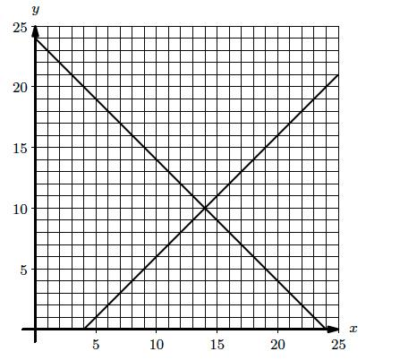
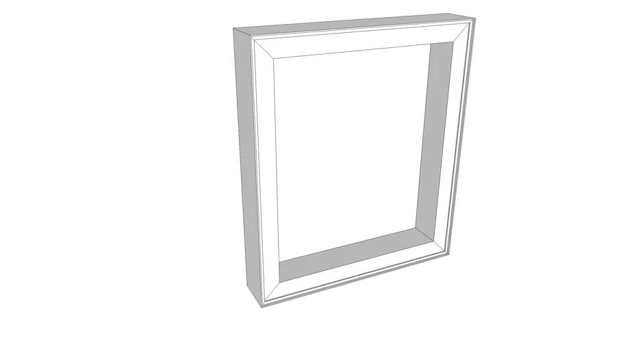
Coplanar lines are useful in:
- Architecture: Designing walls, frames, and flat structural layouts.
- Engineering: Analyzing components that lie in the same plane.
- Technical drawing: Representing edges and construction lines in two-dimensional views.
- Coordinate geometry: Solving equations involving intersections and parallel lines.
- Computer graphics: Identifying line relationships on planar surfaces.

Key Points
# Source: AI Source: Provided by: [Data Path: Persons Table -> ID Column: 1, Name_En Column: Motasem Essam] -> From: [ChatGPT] on [7/25/2026]
- Coplanar lines lie in one common plane.
- They may intersect, be parallel, or coincide.
- Perpendicular lines are coplanar when they intersect at a right angle.
- Coplanar lines do not have to intersect.
- Skew lines are non-coplanar, non-parallel, and non-intersecting.
- The scalar triple product can test coplanarity when the lines are not parallel.

Conclusion
# Source: AI Source: Provided by: [Data Path: Persons Table -> ID Column: 1, Name_En Column: Motasem Essam] -> From: [ChatGPT] on [7/25/2026]
Coplanar lines are an essential concept in solid geometry because they describe lines that share a common plane, even when considered in three-dimensional space. Understanding coplanarity helps distinguish intersecting and parallel lines from skew lines and provides a foundation for more advanced work with planes, vectors, and spatial relationships.

